***NGINX INSTALLATION***

Step 1 : update and install nginx

* sudo apt update
* sudo apt install nginx

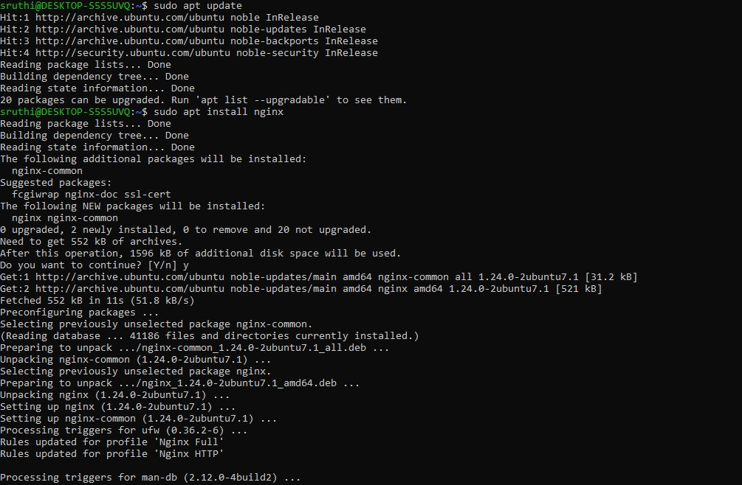

STEP 2 : check the version after installation

* nginx -v



STEP 3 : Start the nginx

* sudo systemctl start nginx
* sudo systemctl status nginx

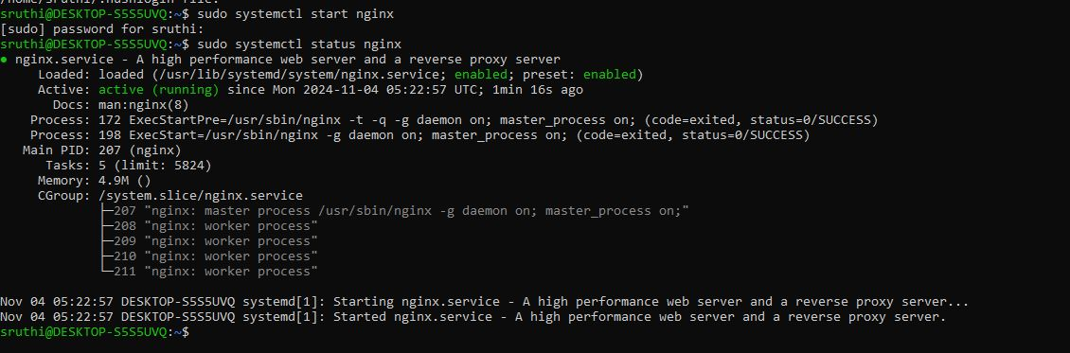

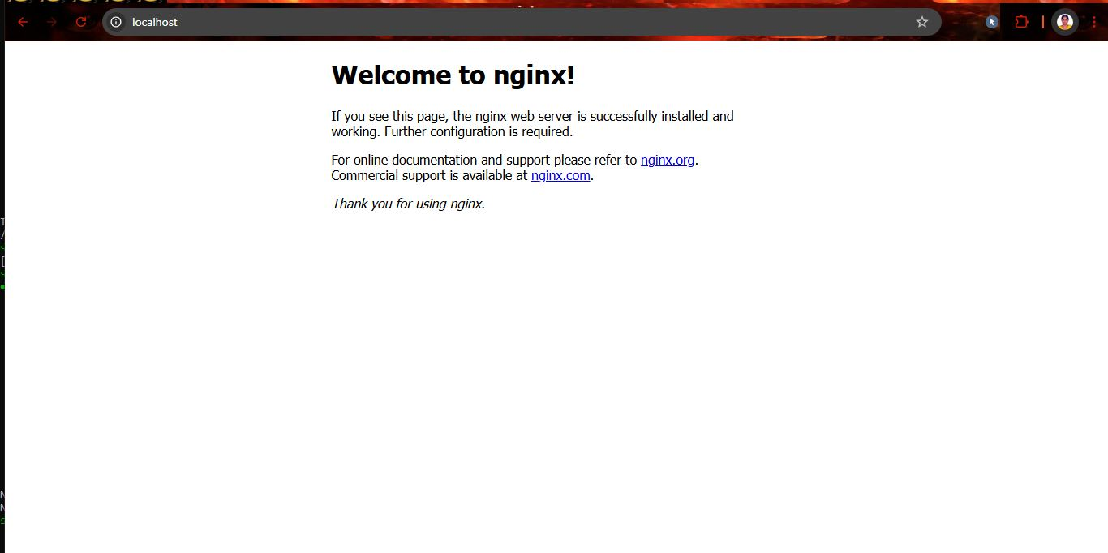

Step 4 : Stop nginx

* sudo systemctl stop nginx

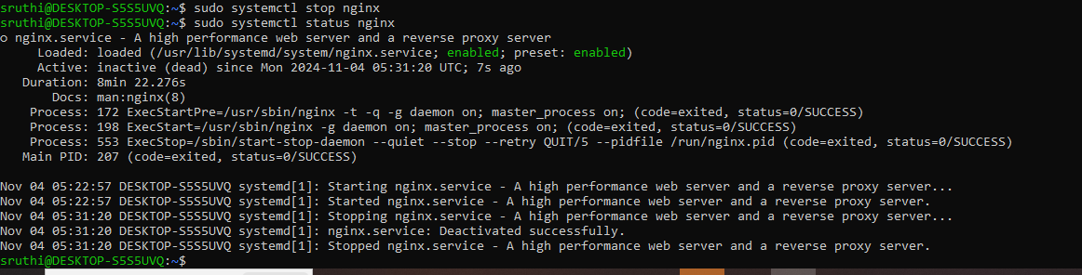

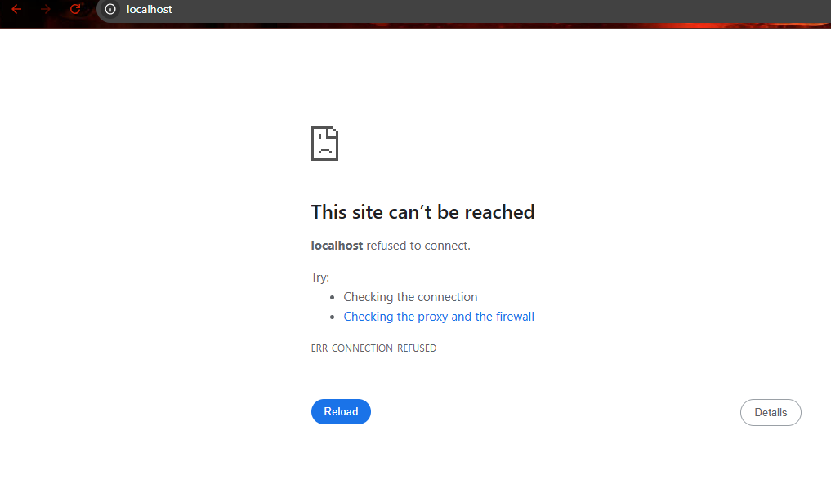

STEP 5 : Kill the process

